TCL 20 5G

Type of device: Mobile
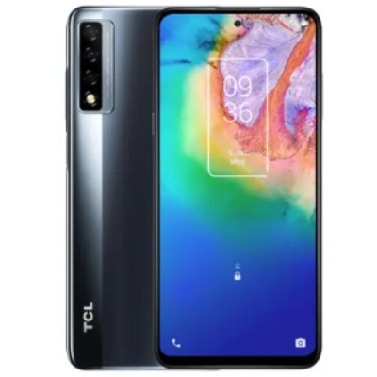

Actual Display Size : 6.67 inches
Button Type : Touchscreen
Operating System : Android
Version Number : Android 10
Network Capability : 3G,4G,5G
Year of Release : 2020
Average Price : $427 as of 10 12 2021

Accessibility Features:

Cognitive
- Additional Instructions
- Copy and Paste
- GPS
- Photo Telephone List
- Screen Timeout Disabled
- Simple Instructions
- Simple Reminders
- Simplify Display
Voice Notes

Hearing Impairment and Deaf
- Allows for sign language communication
- Bluetooth or Wi-Fi
- Closed Captioning
- Front Facing Camera
- Text Messaging/SMS
- Vibrating Alerts - Adjustable
- Video Communications - Two-way
Visual Alerts - Incoming Calls

Vision
- Battery Alert - Audible
- Bluetooth or Wi-Fi
- Braille Display Support
- Brightness Adjustable
- Dictation / Speech-to-Text
- High Contrast Mode
- Personalised Shortcuts
- Power Cue
- Screen Magnifier
- Screen Reader
- Text Size Adjustable
- Voice Control /Personal Assistant
Voiced Menus

Speech
- Allows for sign language communication
- Bluetooth or Wi-Fi
- Messaging Options - Email
- Messaging Options - IM
- Messaging Options - MMS
- Predictive Text
SMS Personalisation and Reuse

Physical
- Automatic Answer
- Bluetooth or Wi-Fi
- Dictation / Speech-to-Text
- Gesture Based Navigation
- Headset - plug connected
- Predictive Text
- Speaker-phone option
- Stylus or Prosthetic Device support
- Switch control option
- Voice Control / Personal Assistant
- Voice Recognition for Accessing Features
Voice Recognition for Dialling

How and where to get it from?
You can buy this phone from Dicksmith, Kogan, Mobileciti, Officeworks, Harvey Norman, and other retailers.

More information is available on:
TCL 20 5G Web Page
TCL 20 5G Specifications Web Page
TCL 20 5G User Manual (PDF Download)

